Lab – Module 6

Shaun Pritchard

Rasmussen College

CDA3315C

Alan Dennis

August 11, 2020

**Lab – Module 6**

**Module 6 lab:**

Using the existing database that were built in a previous lab, I have written basic SQL queries to retrieve the data as follows:

**Lab Objectives Checklist**

* Write an SQL Select Statement
* Apply a Wildcard to the Select Statement
* Apply a Filter to a Select Statement
* Apply Wildcards to a Filter
* Login to the phpMyAdmin Client
* Utilize the MySQL Database Management Tool
* Retrieve Data from a Specific Database Table

**Objective 1 -** Query tables in SQL.

[SELECT](https://enterprisearchitecturewebapp.scm.azurewebsites.net/phpmyadmin/url.php?url=https://dev.mysql.com/doc/refman/5.5/en/select.html) ID, FIRST_NAME, LAST_NAME, TELEPHONE FROM tblcda3315c

**Results:**

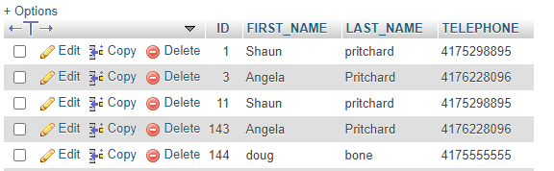

**Objective 2 – Use SQL filter:**

In this section I used 2 different variations to grab the first row of data in column ID and then the rows of data with only the word “ SHAUN” from the FIRST_NAME table.

**Part-1:**

[SELECT](https://enterprisearchitecturewebapp.scm.azurewebsites.net/phpmyadmin/url.php?url=https://dev.mysql.com/doc/refman/5.5/en/select.html) ID, FIRST_NAME, LAST_NAME, TELEPHONE FROM tblcda3315c WHERE ID= 1

**Results:**

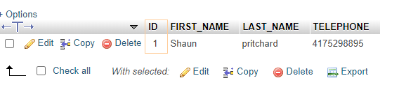

**Part-2:**

[SELECT](https://enterprisearchitecturewebapp.scm.azurewebsites.net/phpmyadmin/url.php?url=https://dev.mysql.com/doc/refman/5.5/en/select.html) ID, FIRST_NAME, LAST_NAME, TELEPHONE FROM tblcda3315c WHERE FIRST_NAME="SHAUN"

**Results:**

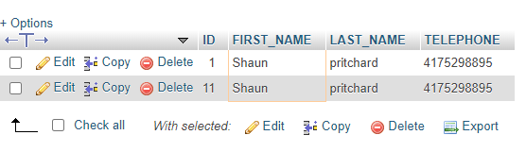

**Objective 3 – Use SQL wildcard :**

This objective is to use wildcard statements to find specific data in a table column to display matching rows. I took it a step further and used more conditional statements to find matching wildcard data from 2 columns as follows. Then in part 2 just for fun I added more conditional statements using OR to find all wildcard data values between the ID 1 through 10.

**Part-1**

[SELECT](https://enterprisearchitecturewebapp.scm.azurewebsites.net/phpmyadmin/url.php?url=https://dev.mysql.com/doc/refman/5.5/en/select.html) ID, FIRST_NAME, LAST_NAME, TELEPHONE FROM tblcda3315c WHERE FIRST_NAME [LIKE](https://enterprisearchitecturewebapp.scm.azurewebsites.net/phpmyadmin/url.php?url=https://dev.mysql.com/doc/refman/5.5/en/string-comparison-functions.html#operator_like) '%ang%' [AND](https://enterprisearchitecturewebapp.scm.azurewebsites.net/phpmyadmin/url.php?url=https://dev.mysql.com/doc/refman/5.5/en/logical-operators.html#operator_and) TELEPHONE [LIKE](https://enterprisearchitecturewebapp.scm.azurewebsites.net/phpmyadmin/url.php?url=https://dev.mysql.com/doc/refman/5.5/en/string-comparison-functions.html#operator_like)'%417%'

**Results:**

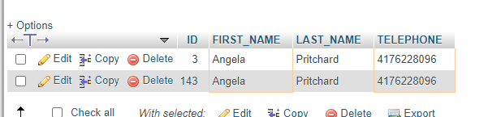

**Part-2**

[SELECT](https://enterprisearchitecturewebapp.scm.azurewebsites.net/phpmyadmin/url.php?url=https://dev.mysql.com/doc/refman/5.5/en/select.html) ID, FIRST_NAME, LAST_NAME, TELEPHONE FROM tblcda3315c WHERE FIRST_NAME [LIKE](https://enterprisearchitecturewebapp.scm.azurewebsites.net/phpmyadmin/url.php?url=https://dev.mysql.com/doc/refman/5.5/en/string-comparison-functions.html#operator_like) '%sha%' [AND](https://enterprisearchitecturewebapp.scm.azurewebsites.net/phpmyadmin/url.php?url=https://dev.mysql.com/doc/refman/5.5/en/logical-operators.html#operator_and) TELEPHONE [LIKE](https://enterprisearchitecturewebapp.scm.azurewebsites.net/phpmyadmin/url.php?url=https://dev.mysql.com/doc/refman/5.5/en/string-comparison-functions.html#operator_like)'%1%' [OR](https://enterprisearchitecturewebapp.scm.azurewebsites.net/phpmyadmin/url.php?url=https://dev.mysql.com/doc/refman/5.5/en/logical-operators.html#operator_or) (ID <= 10)

**Results:**

